Sacred Settlements
(or Sacred Tiny Home Communities)

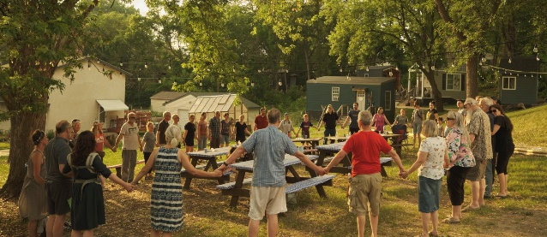
What are Sacred Settlements?

Sacred Settlements (or Sacred Tiny Home Communities, as LA-MN called them) are holistic tiny home communities developed in cooperation with faith communities. They are an innovative, research-based way to address the needs of those experiencing long-term homelessness.

Each resident has their own tiny home for which they pay nominal rent and follow rules set out in a “Good Neighbor” agreement. As a whole, the community shares facilities and amenities such as kitchen and dining spaces, bathrooms, laundry, gardens, workshops, and gathering areas. The land is managed by a religious or social organization to maintain standards for safety and welfare. Specially-trained “Intentional Neighbors” (or missional-neighbors) live in the settlement and work with all the members to ensure that the settlement is healthy and thriving. A team of “Supportive Friends” wrap around each inhabitant coming off the streets to build trusted relationships, walk alongside them as they journey to meet their life goals, and connect them with valuable support services.
Is not this the fast that I choose: to loose the bonds of injustice, to undo the straps of the yoke, to let the oppressed go free, and to break every yoke? Is it not to share your bread with the hungry and bring the homeless poor into your house…Then your light shall break forth like the dawn…If you remove the yoke from among you,…if you offer your food to the hungry and satisfy the needs of the afflicted, then your light shall rise in the darkness your gloom be like the noonday. The Lord will guide you continually and satisfy your needs… [Y]ou shall raise up the foundations of many generations; you shall be called the repairer of the breach, the restorer of streets to live in.

Excerpts from Isaiah 58

Housing advocates often talk about “housing first" – an idea that emphasizes stabilizing those experiencing homelessness in homes before attempting to address the myriad of other issues they face. “Full Community” builds on the “housing first” model, but recognizes the trauma many people have experienced, the need for healing, and the important role of community. The first settlement, at Mosaic Christian Community, is now open following housing code exemptions by the City of St. Paul.

What or Who is Settled?

Settled is a Minnesota-based nonprofit that develops supportive communities (Sacred Settlements) designed to address long-term homelessness. It describes itself is a team of committed and curious families and individuals who have developed this research-based approach of solving homelessness through close relationships with the chronically homeless and those who serve them. See their website at https://settled.org/

*This background paper draws shamelessly from Settled, their website & words (with informal verbal permission).

What is the Full Community Model?

The Full Community model was developed with the chronically homeless in mind who are most often the hardest to house, have the least options available to them, and are the costliest to society. They also have the most to gain as this home may be the first where they have ever felt welcomed, known, and loved. The Full Community Model has five key elements…

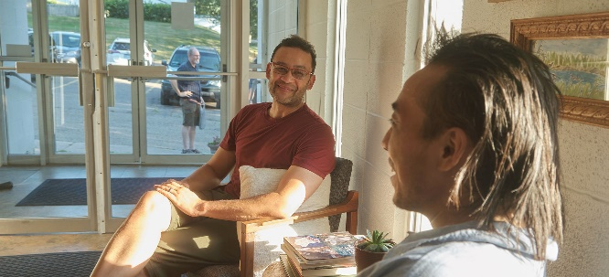
Intentional Neighbors: People who willingly change their current lifestyle to live life alongside formerly homeless neighbors. Many people experiencing chronic homelessness come from family backgrounds that included abuse, violence, neglect, or episodic homelessness. So, the solution comes through healthy relationships with trustworthy people. This helps heal the brokenness.

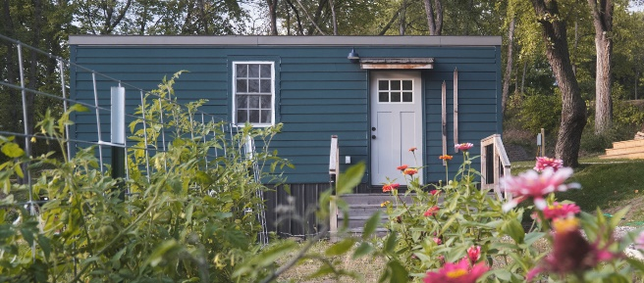
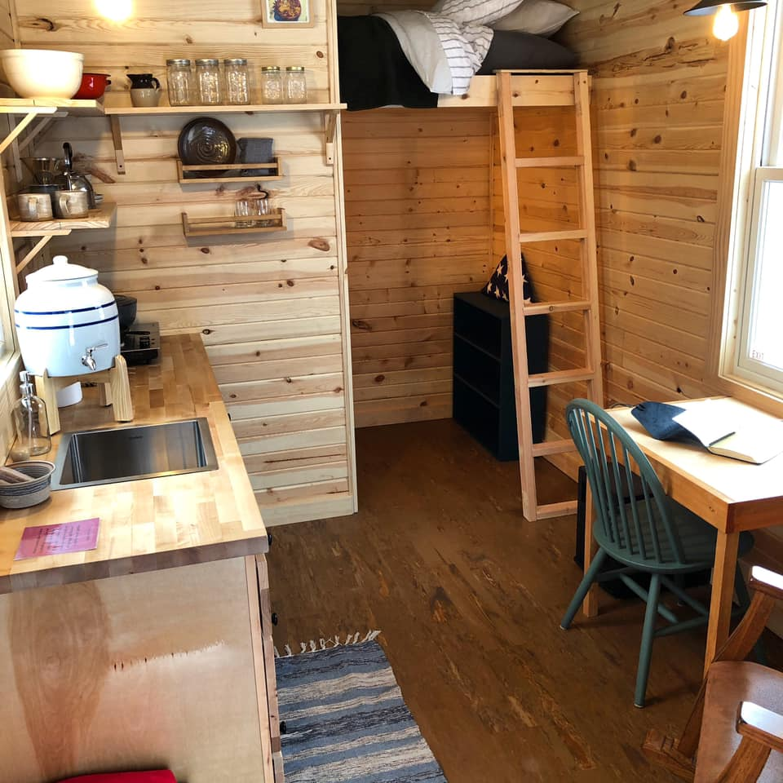
Permanent Homes: Small, simple homes are gathered together to provide safety and to help promote community. A quality, affordable home-base becomes a source of stability. Everyone is required to sign a lease, pay rent, abide by civil law, and abide by the good neighbor agreement. Neighbors can live in their homes for as long as they like, hopefully growing roots and potentially settled in the community indefinitely.
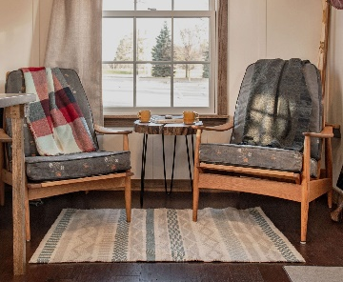
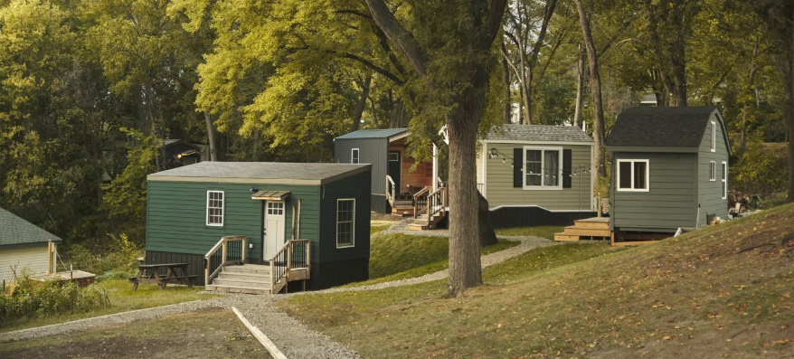
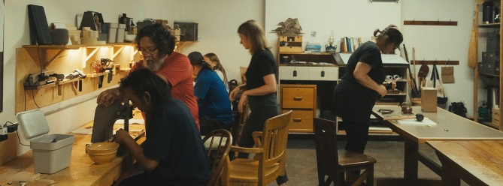
Cultivated Places: The homes are placed on religious land that is carefully adapted to meet the needs of the community. Many faith communities have underutilized areas of their land and buildings. Sacred Settlements fill these areas with meaning, offering daily opportunities to connect with others. The common space is at the heart of each Sacred Settlement, bringing people together for shared meals, games, classes and conversations.

Purposeful Work: Everyone in the community shares in the labor and is compensated fairly for their work. Getting and keeping a job while living on the streets is nearly impossible. Once a person has a place that feels like home, skill-matched work becomes possible, giving direction to life.

Supportive Friends: Each person has one or more helpers to navigate services, helping bridge transportation, communication, and trust gaps that can sometimes occur. Supportive Friends are not paid, but rather are volunteers building genuine trusting relationships, empowering formerly homeless individuals to succeed in their goals, and surrounding them with consistent love and support.

How Can My Congregation be Engaged?

Legislation – Sacred Communities & Ongoing Efforts: Woohoo! The Sacred Settlements legislation passed. It started as HF1872/SF2471 with broad bipartisan support, and finished as part of the Labor Policy Omnibus bill at the end of the Minnesota 2023 Legislative Session (the section labeled “Sacred Communities & Micro-Unit Dwellings”). It goes into effect in January 2024. Although this legislation passed, there remains much to do to adequately address Minnesota’s ongoing affordable housing crisis. Please join Lutheran Advocacy-MN’s email network to engage on future housing & homelessness issues, and be in touch with LA-MN’s director to learn what legislation and talking points are most relevant.

Education: Spend time learning about housing and homelessness in Minnesota – its causes, additional solutions, etc. Consider how churches/people are faith are called to respond. Contact Lutheran Advocacy-MN for suggested resources.

Host a Sacred Settlement: This takes a very deep commitment and long process by a church community, and isn’t for everyone. However, some faith communities are called to make this commitment. Contact the nonprofit, Settled, for more information about this process.

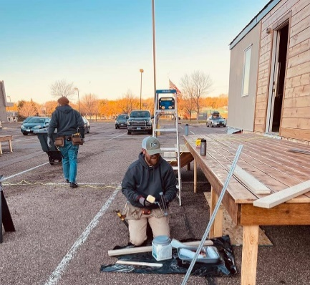
Sponsor a Tiny Home: This can be done in collaboration with other churches or as project of your congregation. Two ELCA congregations participated in the construction and furnishing of units in the of the Mosaic Settlement (Cost: roughly $35,000 – $50,000).

Other Ways to Help:

Identify a Sacred Settlement Being Formed, then…
- Clear the Ground where the Sacred Settlement will be located
- Help Remodel the Faith Community to Provide Common Space
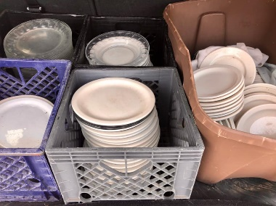
- Kitchen
- Common Room
- Showers/Rest Rooms
- Bookshelves
- Help Furnish or Supply Common Areas
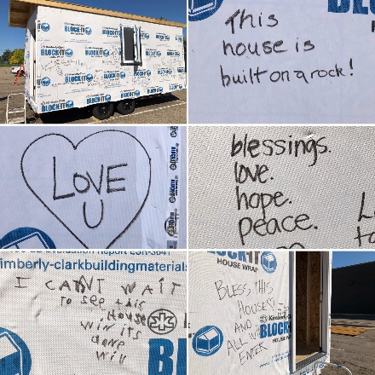
- Kitchen Supplies
- Community Table(s)
- Dishes for Community Meals
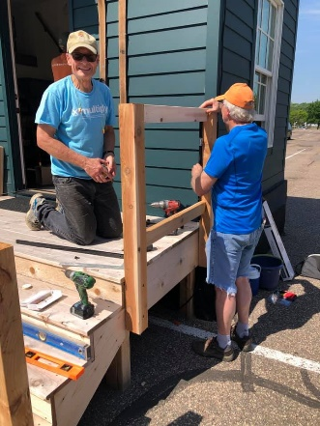
- Books
- Games
- Build or Help Build a Tiny Home
- Framing
- Exterior/Interior
- Cabinets
- Paint
- Finishing
- Porch
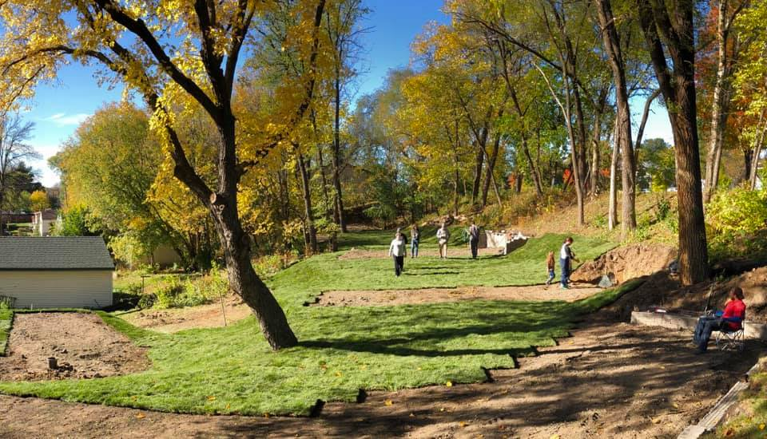
- Skirting
- Prepare a Tiny House to be Someone’s Home
- Furniture
- Quilt
- Bedding
- Basic Kitchen Supplies (hotplate, dishes, tea kettle, pan)
- Prepare the Grounds
- Reseed Lawn/Lay Sod
- Build Paths
- Fire Pit/Outdoor Furniture
- Clear Garden Space/Plant Garden
Continued

Other Ways to Help, continued:

Build Relationships…
- Bring/Join Community Meals (1x/week, 1x/month, 1x/quarter?)
- Join Periodic Game Nights
- Supply Volunteers
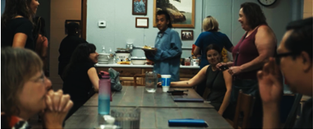
- Supportive Friends
- Rides to Appointments/Jobs
- Participate with Residents Caring for Gardens/Property
- Carry Water to Tiny Homes (for basin in home)
- Plan/Participate in Community Fun Nights
- Join Outdoor Activities
- What else can you think of?
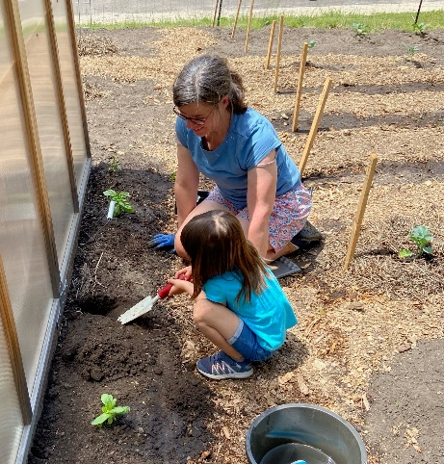
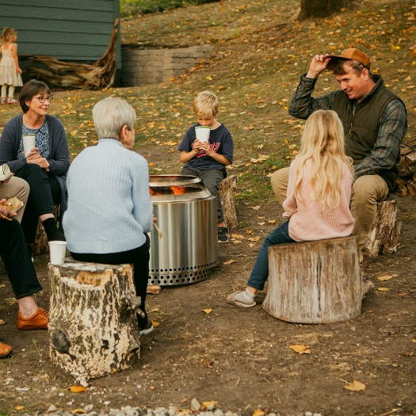
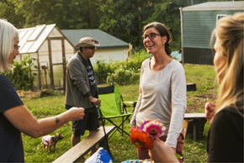
- What can you and your congregation do to contribute to the building of genuine trusting relationships, the empowering of formerly homeless individuals to succeed in their goals, and to surround them with consistent love and support?
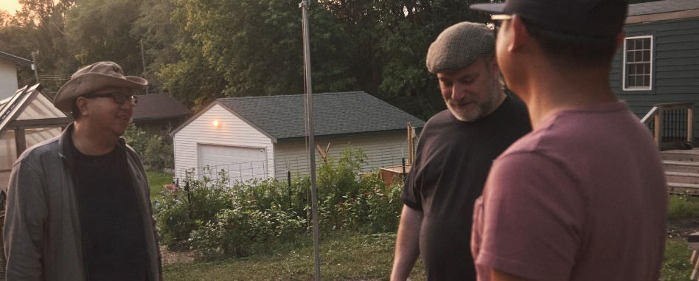

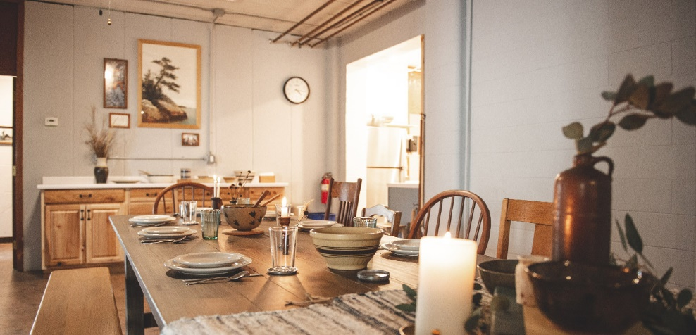
The common home is at the heart of each Sacred Settlement, bringing people together for shared meals, games, classes and conversations.

